Experiment No. 07

*Lab 07 –Python Tuples.*

1.Use  built-in min and max functions to perform the task of getting the minimum and maximum value of in a list of tuples for a particular element position in a tuple.

Sample = [(2, 3), (4, 7), (8, 11), (3, 6)]

**CODE:**

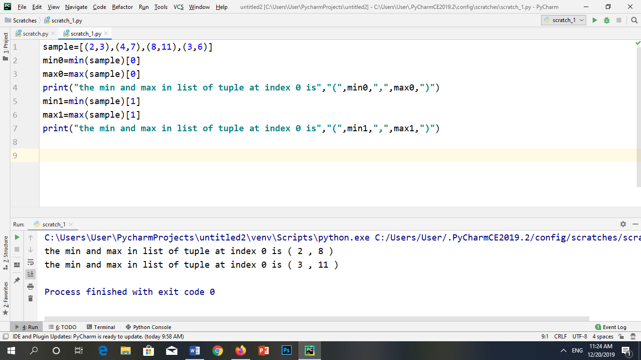

**OUTPUT:**



2. A dartboard of radius 10 and the wall it is hanging on are represented using the two dimensional coordinate system, with the board’s center at coordinate (0; 0). Variables x and y store the x- and y-coordinate of a dart hit. Write an expression using variables x and y that evaluates to True if the dart hits (is within) the dartboard, and evaluate the expression for these dart coordinates:

(a) (0,0)

**CODE:**

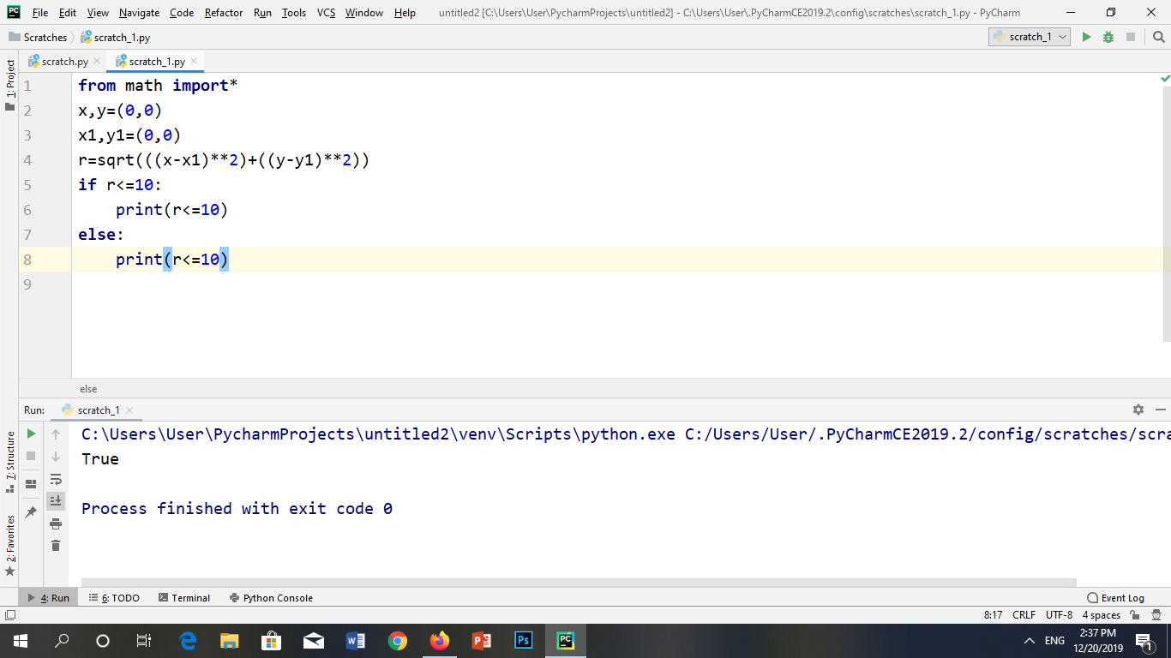

**OUTPUT:**



(b) (10, 10)

**CODE:**

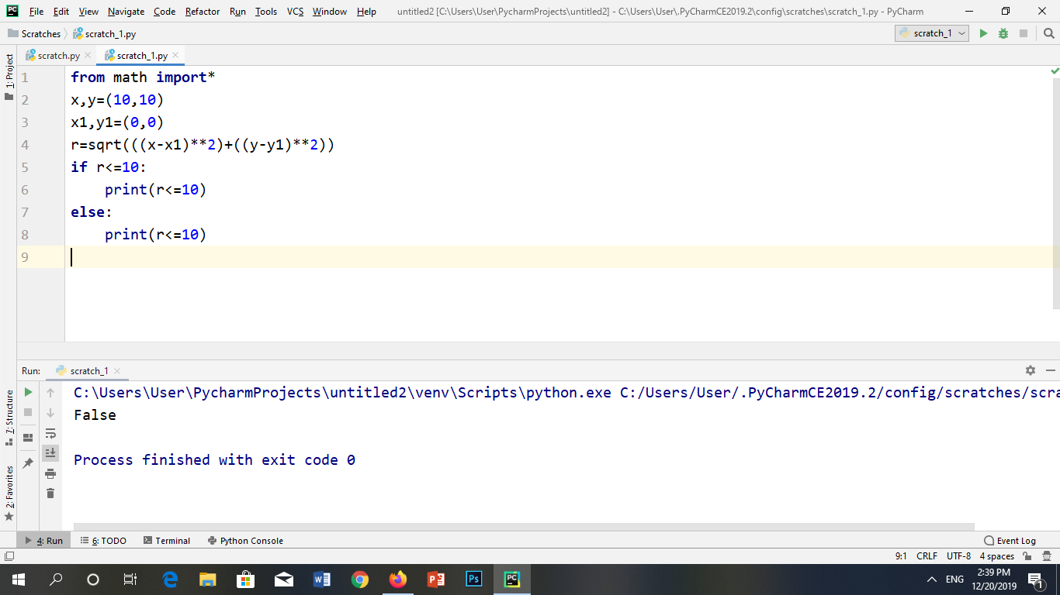**OUTPUT:**



(c) (6,6)

**CODE:**

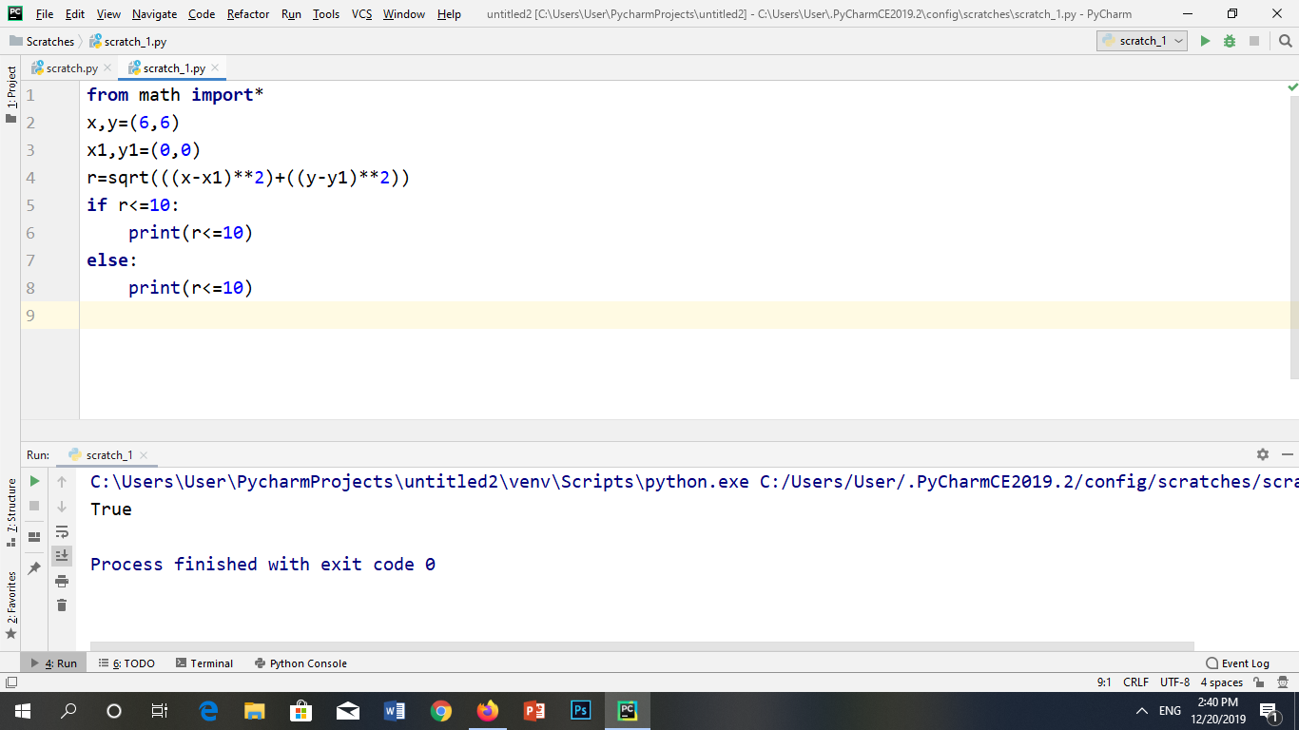

**OUTPUT:**

****(d) (7,8)

**CODE:**

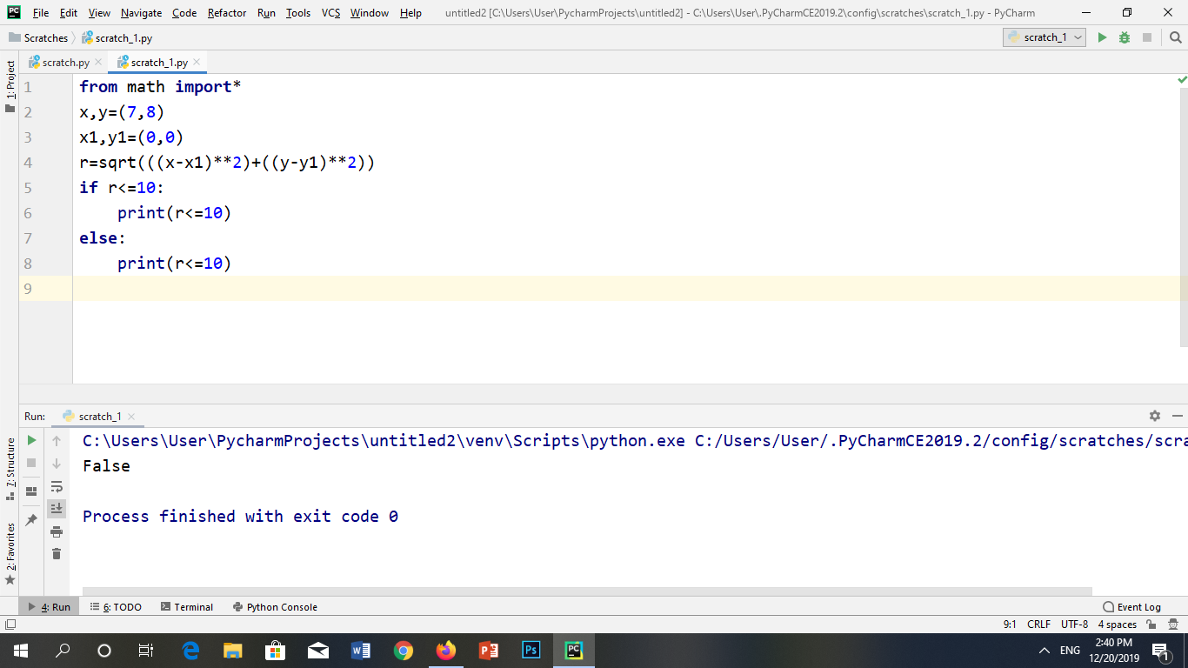

**OUTPUT:**



3. Write Python expressions corresponding to these statements:

(a)The number of characters in the word "anachronistically" is 1 more than the number of characters in the word "counterintuitive."

len(**"anachronistically"**)-len(**"counterintuitive"**)

(b)The word "misinterpretation" appears earlier in the dictionary than the word "misrepresentation."

min(**'misinterpretation'**,**'misrepresentation'**)

(c)The letter "e" does not appear in the word "ﬂoccinaucinihilipiliﬁcation."

**'e' in 'ﬂoccinaucinihilipiliﬁcation'**

(d)The number of characters in the word "counterrevolution" is equal to the sum of the number of characters in words "counter" and "resolution."

len(**'counterrevolution'**)==len(**'counter'**)+len(**'resolution')**

4. Write a program in Python that holds an empty tuple and fill that tuple after taking user input for names of provinces of Pakistan n fill an empty tuple and print.

**CODE:**

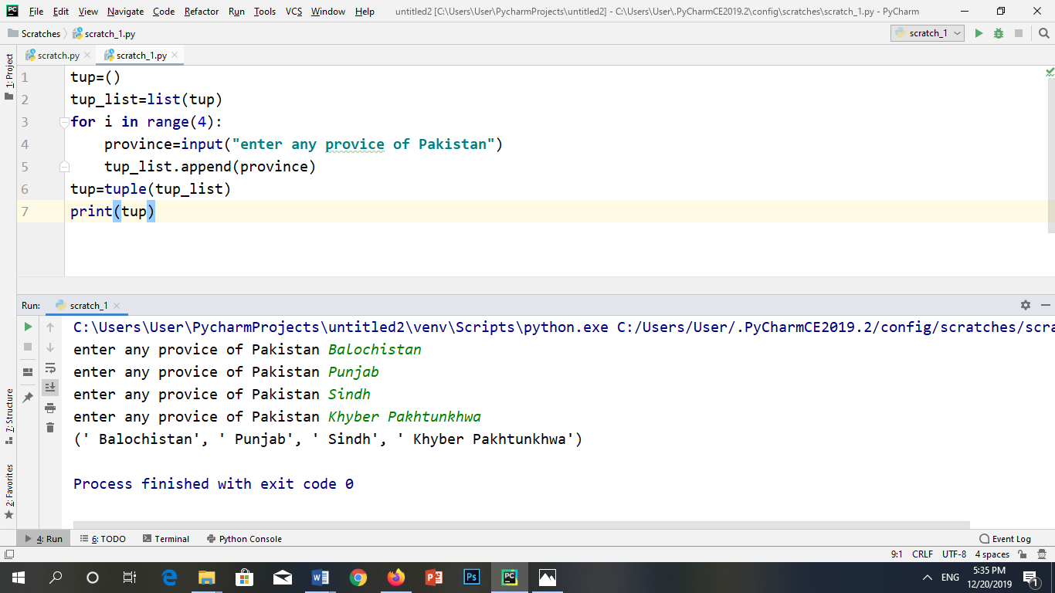

**OUTPUT:**

